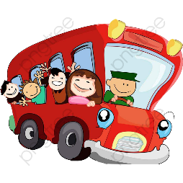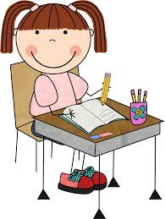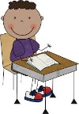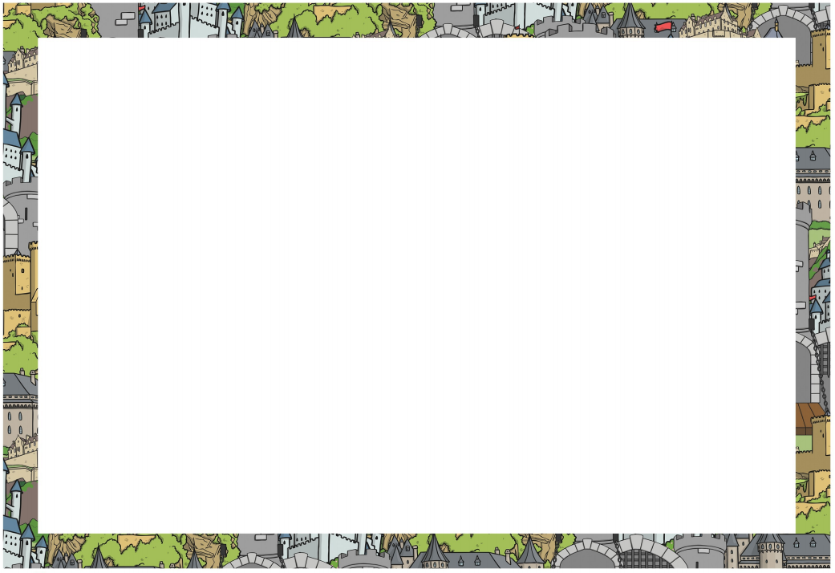

**PPA**

**(Planning, Preparation and Assessment Time for Teachers)**

This will take place on a **Tuesday** morning. Mrs Mullan will work with the children during this time on a variety of creative activities linked to our class topic.

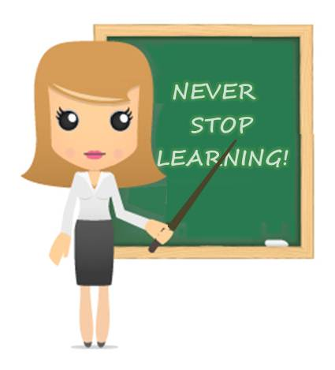

**Spelling**

Spelling lists will be sent home on Fridays and the children will be tested on the words on the following Friday. The spelling menu given last term will give you some ideas of activities you can use to support your child when learning their words at home.

**Money**

Dinner money is paid using our online SQUID system. Fruit costs £1 per week and can be paid weekly on a Monday or half termly if you prefer. Please place fruit money in a sealed envelope with your child’s name and amount enclosed written on the front. Any other money for trips etc. will also need to be sent into school in a sealed envelope with your child’s name and class written on the front.



**P.E**

PE is on **Thursday**. This term we will be focusing on **game skills** in the hall and the children will need to wear a **T-shirt and shorts/leggings.** PE kits should be sent into school in a **labelled bag** and will be sent home half termly. Please ensure that all items of kit are labelled too. For safety reasons, please ensure **all jewellery is removed** before school on PE days otherwise your child will be unable to take part in the lesson.



**Visits/Experiences**

This term, we are planning a visit which will link with our topic, ‘Castles and Fairy Tales’. More information will be sent out nearer the time.

**Homework**

In addition to the weekly reading and spelling lists we have devised, a half termly homework menu will also be sent home. This has a range of home learning activities for your child to choose from and complete at their own pace. We would like the children to complete **at least 1** of the activities and bring it into school on the specified date but they can do as many as they choose.

**Reading Books**

Reading books will be sent home every Friday and should be returned on the following **Wednesday.** It is important that you listen to your child reading their book several times as this will improve their fluency. Please write a comment and/or sign their reading journal to show that you have read with them in order for us to change their book.

**Water Bottles**

 It is important that the children keep hydrated throughout the day so water bottles can be sent in for the children to have a drink during class time – **WATER ONLY**. Please label the bottles so there is no confusion.

We hope that your child will continue to find their time in Year 1 exciting, challenging, and most of all enjoyable. If you have any queries or concerns, please do not hesitate to speak to us at the end of the day or contact the school office to make an appointment. Thank you for your support, Mrs Aitchison, Miss Davies and the Year 1 team.